Media Literacy
Visual 1
- Who is the intended audience in this visual? (1 mark)
- charity donors
- families of sick children
- fast food customers
- hospital workers
- What is the purpose of repeating the phrase, “This is where…” throughout the visual? (1 mark)
- create emphasis
- encourage dialogue
- identify stereotype
- provide comic relief

- In the context of the visual, what does the word “sanctuary” (line 1) mean? (1 mark)
- chapel
- dwelling
- haven
- hostel
- What is the dominant media strategy used? (1 mark)
- celebrity endorsement
- facts and figures
- plain folks
- shock appeal
Constructed Response (6 marks)
- With specific references, explain how two visual elements contribute to the overall message of the visual.

Visual 2

- What is the effect of the hand coming out of the snow? (1 mark)
- create bias
- demonstrate contrast
- imply scale
- reinforce message
- What best describes the purpose of the visual? (1 mark)
- advertise
- entertain
- mock
- scare
- What is the visual promoting? (1 mark)
- cell phones
- phone cases
- weather patterns
- winter preparedness
- In the context of the visual, what does the word “resilient” mean? (1 mark)
- delicate
- elastic
- tough
- weak
Constructed Response
- With reference to two specific visual elements, state a theme for this visual. (6 marks)

Visual 3

- What is the focal point of the visual? (1 mark)
- girl’s mouth
- her eyes
- Listerine breath tabs
- “No one needs to know” text
- What mood is created by the facial expression of the woman? (1 mark)
- anger
- contentment
- horror
- worry
- What is the form of the visual? (1 mark)
- advertisement
- brochure
- poster
- web page
- What is suggested by the police tape over the girl’s mouth?
- She has bad breath.
- She is not permitted to speak.
- She has nothing to say.
- She has fresh breath.
Constructed Response
- With specific references, explain how two media strategies are used to contribute to the overall message of the visual. (6 marks)

Visual 4

- Who is the intended audience of the visual? (1 mark)
- bullies
- dog owners
- general public
- SPCA
- What is the purpose of this visual? (1 mark)
- to advertise an organization
- to encourage adoption
- to provoke action
- to raise debate
- What is the tone of the visual? (1 mark)
- adoring
- enraged
- serious
- understated
- What is the purpose of the dash in the phrase, “... and violent people tend to keep on being violent – until someone speaks up.”? (1 mark)
- to create suspense
- to provide a transition
- to establish mood
- to emphasize pause
Constructed Response (6 marks)
- Explain the effectiveness of shock appeal and emotional appeal in the visual. Make a specific reference to each media strategy. (6 marks)

Visual 5
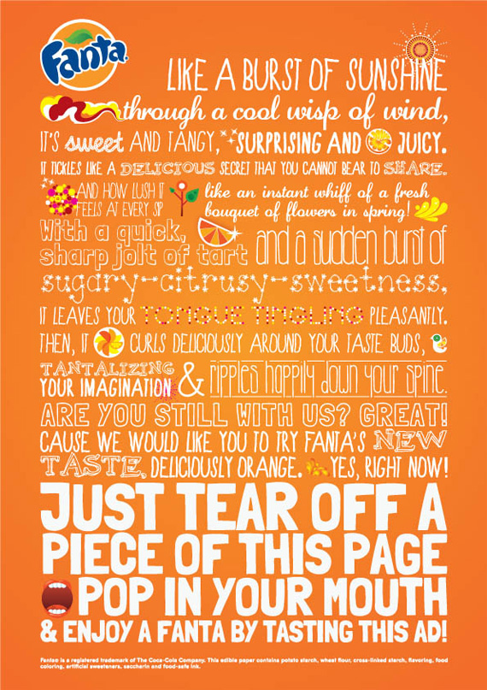

- What style is mainly used in this visual? (1 mark)
- analytical
- description
- exposition
- persuasion
- Which device is evident in, “Are you still with us?” (1 mark)
- conflict
- hyperbole
- parallel structure
- rhetorical question
- What is the form? (1 mark)
- advertisement
- blog
- picture
- poster
- What device is evident in “It leaves your tongue tingling pleasantly.”? (1 mark)
- alliteration
- assonance
- euphony
- onomatopoeia

Constructed Response
- Using two specific references identify and explain the mood of the visual. (6 marks)

Visual 6
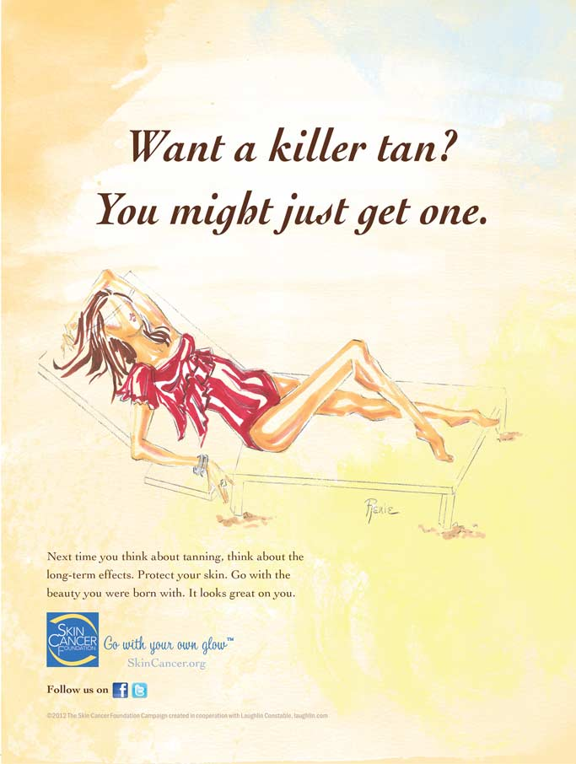
- What is the effect of colour in the background? (1 mark)
- create emphasis
- demonstrate bias
- develop mood
- establish balance
- What term describes, “Go with your own glow.”? (1 mark)
- headline
- logo
- propaganda
- slogan
- What is the subtext of the statement, “Want a killer tan? You might just get one.”? (1 mark)
- Long term tanning can cause major health problems.
- Moderate sun exposure is acceptable.
- Tanning will make you look and feel good.
- Wearing sunscreen prevents skin cancer.

- What is the main purpose of the visual? (1 mark)
- to criticize
- to entertain
- to inform
- to reflect

Constructed Response
- Using two specific references, explain the contrast between the tone and the visual elements. (6 marks)

Visual 7
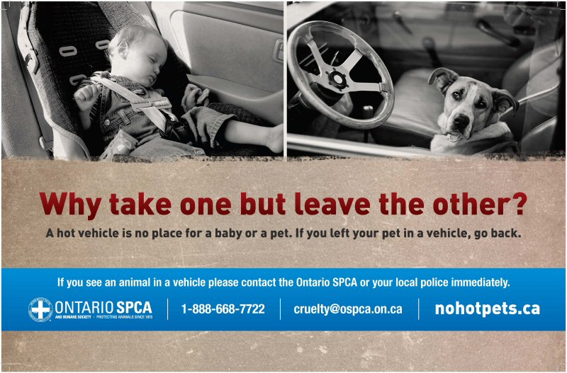
- Which best represents an endorsement? (1 mark)
- cruelty@ospca.on.ca
- nohotpets.ca
- local police
- Ontario SPCA

- What is the purpose of the visual? (1 mark)
- Criticize those who leave children alone in cars.
- Encourage people to be considerate of animals.
- Prevent parents from leaving children and animals unattended.
- Reinforce that children are more important than animals.

- What visual element is represented by having the two pictures side by side? (1 mark)
- angle
- balance
- focal point
- proportion

- Which of the statements best represent the overall message? (1 mark)
- Children should not be in a car during a hot day
- Citizens have a responsibility to protect animals
- Government should create awareness around car safety
- Take responsibility for your actions

Constructed Response
- With specific references, explain how two visual elements contribute to the tone of the visual. (6 marks)

