English 3202/2202

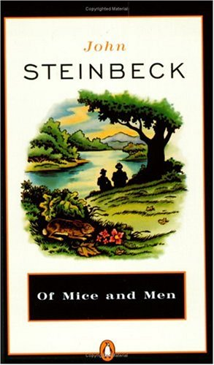
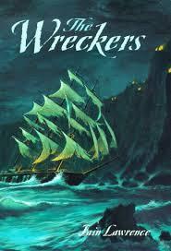

Teacher: Ms. C. Thompson
cathythompson@nlesd.ca

Tentative Timeline
Term I

Unit I - Survival

September 5 –
October 3 Film Study
The Grey
The Hunger Game / Catching Fire
Evaluation: Reading assignments (questions)

October 6 Novel Study
November 14 Of Mice and Men

Evaluation: Reading assignments, test

November 17 – Short Story Unit
December 19 Passages (Text)
A variety of poems and short stories
One play from
Searchlights (Text)

Evaluation: Journal entries

The midterm examination will cover material from September to January.

Term 2 February - June
Communicate -Business letters, Personal letters, etc.
Visual Text - Manuals / Advertisements/Newspapers
Drama - Searchlights - short play, role play
Novel - Of Mice and Men
Journal Writing

Term 2
The final examination will cover from mid-term to June.
NOTE: Students receiving a grade of 50 or more on the final exam will receive a pass on their final report.

Evaluation Components

Writing and Representing - 30%

Speaking and Listening - 10%

Reading and Viewing - 30%

Midterm Examination - 15%

Final Examination - 15%
Weightings
Tests and Assignments x3
Quizzes x2
Activities, including
Listening and Representing x2

