Practice Test – ELA 2201 (Visual and Poetic Analysis)
Section A: Visual (9 marks total)

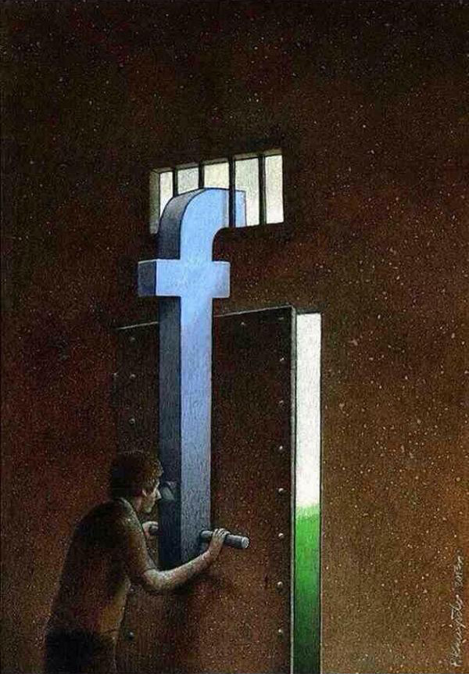

1. What objects help achieve balance in the visual?
a. the blue “f” and the background
b. the blue “f” and the open door
c. the man and the grated window
d. the open door and the grated window
2. Who is the targeted audience for this visual?
a. people in prison
b. people in the military
c. people researching social behaviour
d. people using social media
3. Why does the artist use the chosen background?
a. to achieve balance
b. to achieve unity
c. to create contrast
d. to reinforce scale
Constructed Response Item - Answer any ONE question. (6 marks)
4. What is the main message of this visual. Using TWO visual elements, support your selection of theme.
Discuss the effectiveness of colour in this visual. Provide TWO supports.

Section B: Poetry (16 marks)
Digital Poem
I wander between Facebookian islands
following fallen Youtubean prophecies
and a king reigning over Photoshop dump
I sail with my beloved arrow
brave and faithful to my mouse 5
which digs deep into the Abyss-net
My adventures are drenched
by vicious roulettes twisting
in robotic voices of commercials
Shakespeare’s Hamlet was staring at a .jpg skull 10
on his cold neon monitor
monologuing about the meaning
of word, excel, point of power and paint
I sought an essential word
in the global dictionary 15
it was forever deceased
all useless words far away
I chased the meaning of life
I embodied several characters
Music everywhere and nowhere 20
and unknown lonely art
My monitor is so far away
but computer and technology
are all our lives
isn’t it? 25
There’s so much to write
so much to read
so much to see
so much to discover
Alas, we lost ourselves 30
Swift walkers on the edge
of this beautiful Era of Inconsistency
Selected Response Items: Circle the letter of the correct or BEST answer. (6 marks)
5. What mood is created in this poem?
a. Cynical
b. Inspirational
c. Ironic
d. Sarcastic
6. What is the best meaning of “embodied” in line 19?
a. Defined
b. Embraced
c. Identified
d. Personified
7. Line 10, “Shakespeare’s Hamlet was staring at a .jpg skull”, is an example of what literary device?
a. Allusion
b. Analogy
c. Anecdote
d. Assonance
8. Which of the following best describes the form of this poem?
a. Ballad
b. Blank verse
c. Free verse
d. Narrative poem
9. Which literary device is represented by line 11, “his cold neon monitor”?
a. Olfactory and auditory
b. Olfactory and visual
c. Tactile and olfactory
d. Tactile and visual
10. Which of the following lines is an example of alliteration?
a. “and a king reigning over Photoshop dump” (line 3)
b. “Music everywhere and nowhere” (line 20)
c. “on his cold neon monitor/monologuing about the meaning” (lines 11-12)
d. “robotic voices of commercials” (line 9)
Constructed Response Items - Answer any TWO questions (10 Marks)
15. Provide a more effective title for this poem. Support using two (2) examples. (6)
16. Explain the effectiveness of ONE of the following quotations: (4 )
a. “My adventures are drenched” (line 7)
b. “so much to read/so much to see/so much to discover/Alas, we lost ourselves” (lines 27-30)
17. What do you think is a theme for this poem? Support using TWO examples from the text. (6)

18. What is the poet’s message to the readers in this poem? Provide two details that support your understanding. (6)

19. What is the literal meaning of this poem? Provide TWO supports. (6)

20. How is imagery used effectively in this poem? Provide ONE support to show this (4)

